Regional Training on Hydrodiplomacy & Negotiation Skills for
IGAD Water Resources Protocol Negotiation Members
27-28 February 2017 -- Addis Ababa, Ethiopia

Negotiation Simulation Exercise: The River Wide Basin case
Elbia, Kufra and Blanconia are three States situated in the drainage basin of the River Wide, which is the principal source of water for these countries. The total annual flow of the River Wide is about 100 Km3 (with 86% coming from the territory of Blanconia).

Elbia (population 50 mln) and Kufra (population 20 mln) – two downstream countries – have traditionally used River Wide waters for irrigation while Blanconia, the least developed State of the basin, has relied almost entirely on rainfall. The distribution of rainfall in the basin is extremely uneven – from 1000 mm/year in Blanconia to 50-200 mm/year in Elbia. Arable land with various types of irrigation in the three countries is distributed as follows: Elbia – 3.0 mln ha, Kufra – 1.7 and Blanconia – 100.000 ha. All three countries possess considerable and yet untapped groundwater resources, including some transboundary aquifers. However their volume, location and relation to surface waters have not been properly examined.

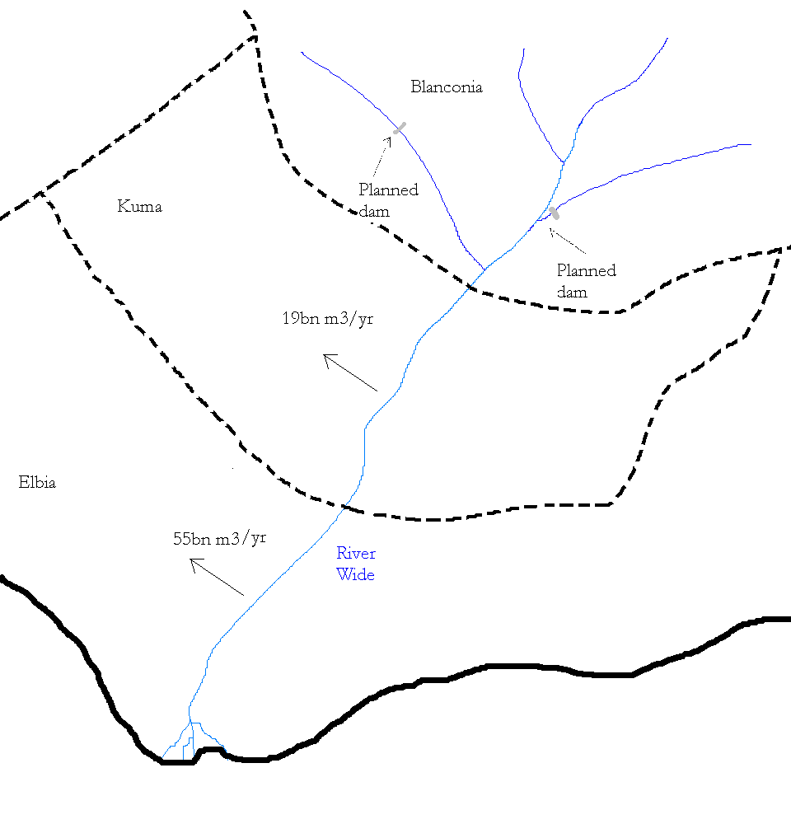
Currently Elbia is using 55 Km3 of water and Kufra - 19 Km3. Blanconia, with its population of 35 mln people, is currently using 6.0 Km3 of the River Wide basin waters. Owing to the population growth it is expected that the water demand will significantly increase in all three countries. Elbia is currently planning to develop new irrigation schemes to meet projected shortfall in food supply and to increase its cotton production for export. Elbia have significant reserves of hydrocarbons (gas) which it is planning to develop and to export to neighbouring countries.
Kufra

Blanconia is planning to construct two large dams with hydropower stations and reservoirs of a total volume of 40.0 Km3 on the tributaries of the River Wide to control the variations in its flow, increase agricultural production through irrigation and especially hydropower generation for its economic development. Blanconia has very limited known reserves of other energy resources. At the same time, Blanconia does not have the capacity to construct reservoirs on its own, without financial resources from the outside. In order to implement the project Blanconia has requested financial assistance from the World Bank.

The area where one of the dams is to be constructed (Zutuland Dam) has been affected by the continuous internal conflict between the central government of Blanconia and one of the ethnic minority groups – Zutu – who have been striving to achieve greater autonomy. In fact, the government plan to build the dam and hydropower station in this region was driven by its desire to improve the livelihood of the local population (through irrigation and better energy supply) and thus reduce the potential for conflict. However, the project will entail serious resettlement of the local population –up to 100 000 people will have to be moved if the reservoir of the planned capacity of 25 km3 is created. For many years the government of Elbia provided clandestine logistical and financial support to Zutu in their struggle for greater autonomy. At some point in the past this support had been significantly reduced due to improved relations between Elbia and Blanconia. However the upstream development plans have caused these relations to deteriorate once again to the extent that Elbia has begun to create serious obstacles for transit of construction materials and equipment via the only railroad crossing its territory and connecting its main seaport and Blanconia, a land-locked country.

Kufra and Elbia are generally opposed to the upstream plans by Blanconia. However, they have an interest in better flood control in the basin. Kufra fears that development upstream might cause harm to its vast Wetlands. But it also recognizes that the annual floods require mitigation measures.

Kufra and Elbia insist that the upstream plans should not go ahead without their consent. Blanconia claims that since the dams are being constructed on the tributaries of the River Wide, which are not transboundary as such, this should be of little concern to the lower riparian States.

Kufra and Elbia are parties to the 1997 UN Watercourses Convention and are considering acceding to the 1992 UNECE Water Convention. Elbia has developed its agriculture earlier than other basin States, and claims its water utilisation as an existing use which should have priority over planned uses and which will be put at risk by any significant development upstream. The development plans in the riparian countries have resulted in a conflict of uses of the River Wide waters. Numerous efforts to reconcile these differences through consultations have failed. Prompted by these events, Elbia and Kufra have asked the World Bank not to provide financial support for the projects, as this will cause serious harm to their traditional water uses.

There is no basin treaty for the River Wide and the Paravian Economic Union – a regional development organization, which Elbia, Kufra and Blanconia are members of, - recommends that the three States should develop such agreement and create a joint institution with a mandate to be a platform of coordination for water management and environmental protection in the Basin. The Paravian Union has a Development Fund which could be used to partly finance planned activities in all three basin States provided they reach an agreement.

Team 1 (representing Blanconia), Team 2 (Kufra) and Team 3 (Elbia) must prepare a concise statement outlining some principal arguments, which their respective countries may rely upon in arguing their case in the World Bank. Team 4 (Expert Panel) will consider the case on behalf of the World Bank. The Expert Panel must determine the facts and make recommendation considering the facts of the case and legal aspects such as principles of ERU, obligation not to cause significant harm, prior notification of planned measures, benefit sharing, duty to cooperate, and any other relevant principles.

The three countries and the World Bank as a mediator have to negotiate a trilateral agreement, outlining a framework of cooperation. The teams are free to choose any particular model of such an agreement and which issues should be covered.

The teams are expected to use:

1992 UNECE Water Convention

1997 UN Watercourses Convention

WB Operational Policy and Bank Procedures 7.50

The teams may use other water treaties as reference materials

